Artopia game

Part 1

Museum Curation



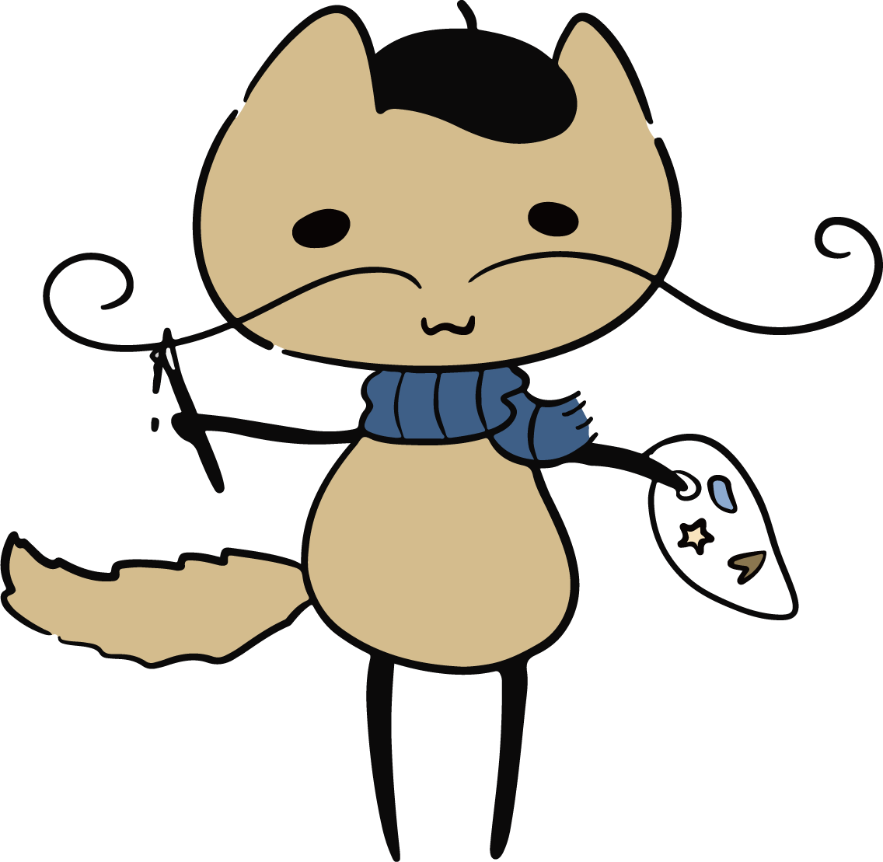

1. Cat in background → gives instructions
2. Artwork list on the right (include artworks, scroll up & down)
3. Drag to place, click and zoom
4. After placing all 3 works, click to confirm
5. Rating and tips (at least 1 star)

**Artwork Info:**

Irises

Vincent van Gogh

Self-portrait with grey felt hat

Vincent van Gogh

Water Lilies and Japanese Bridge

Claude Monet

Rouen Cathedral, West Façade, Sunlight

Claude Monet

Washerwomen

Paul Gauguin

Self-portrait with Small Monkey

Frida Kahlo

Madonna in the Meadow

Raphael

Dort or Dordrecht: The Dort packet-boat from Rotterdam becalmed

Joseph Mallord William Turner

Gleaners

Jean-François Millet

The Anatomy Lesson of Dr Nicolaes Tulp

Rembrandt van Rijn

Madonna of the Rosary

Caravaggio

The Massacre of the Innocents

Peter Paul Rubens